NGCX – 66681
Dynamic-planner-s-api
Triggering Welcome Email
Dynamic Planner System API is to connect with Third Party System Dynamic Planner from MuleSoft.
Below is the list of operations I have worked on Dynamic Planner System API.
RAML :
Created new endpoint to trigger welcome Email after the partner was created successfully in salesforce.
EndPoint : /admin/v1/employees/:employeeIds/emailrequests?type=welcomeEmail
Pre-Defined : The above endpoint is predefined before RAML Modification. From postman we are created this endpoint in RAML and as well as in DEV part in ESB.
-- Subscription key
- Body { … }
- employeeIds with value
These are all predefined in postman which using OAuth 2.0 for collection.
Before send a request, have to generate access token which will be stored in object store.
If the employeeId is valid it returns the welcome Email Body, with emailrequests as query Parameter and welcomeEmail as Enum in RAML.
Created folders and inside it object files, data types and example files in Anypoint Platform during RAML Creation.

Development Part in Studio:
In bitbucket created a new feature branch with Jira ticket number. From there cloned the repo under the local directory path.
After cloning, scaffold into Anypoint studio.
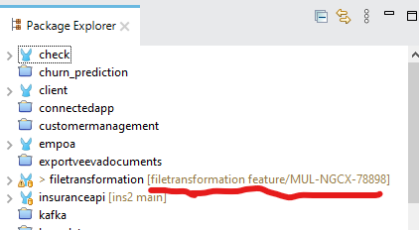

To trigger the welcome email we have to access the token from anypoint platform. With the help of flow reference it calls a authorization-token-sub-flow to retrieve token using Global Object Configurations.
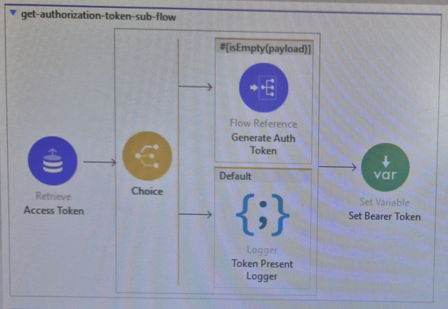

After Retrieving the access token, via choice router…routes the message to the different way, if the payload is not empty moves to another subflow via flow reference which request the token from external API and stores the token using object store store connector.
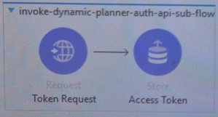

Then it returns to the Main flow (email trigger flow), here we already defined ENUM(WelcomeEmail) in RAML Part.
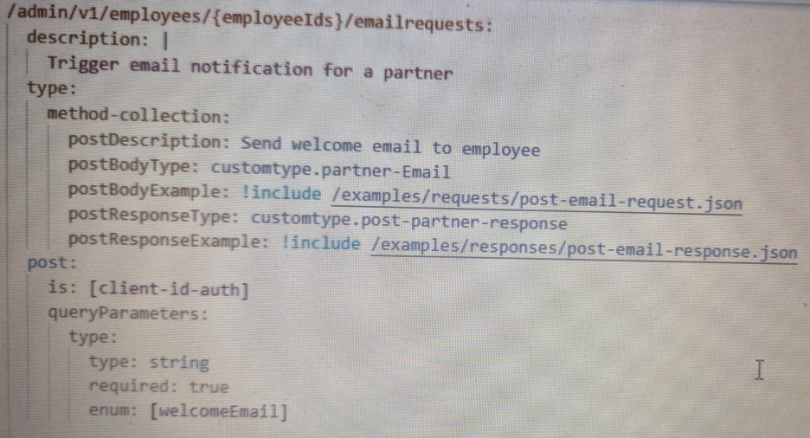

message='#["Auth token received. Start Dynamic Planner API request"]'>
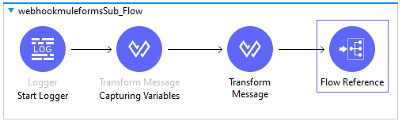
It triggers the subflow, with the Employee ID request sent to external API and triggers the email body which is defined in JSON Format.

